

CUSTOMER CARE REGISTRY

**PROJECT PLANNING**

**TEAM DETAILS:**



**Team No :** PNT2022TMID46076

**College Name :** University College of Engineering

**Department :** Computer Science & Engineering

|  |  |
| --- | --- |
| Date | 03 nov2022 |
| Team ID | PNT2022TMID46076 |
| Project Name | Customer Care Registry |
| Maximum Marks | 7 Marks |

**PROJECT PLANNING**

# Product Backlog, Sprint Schedule, and Estimation (4 Marks)

## Use the below template to create product backlog and sprint schedule

|  |  |  |  |  |  |  |
| --- | --- | --- | --- | --- | --- | --- |
| Sprint | Functional  Requirement (Epic) | User Story  Number | User Story / Task | Story Points | Priority | Team Members |
| Sprint-1 | Registration | USN-1 | As a customer, I can register for the application by entering my email, password, and confirming my password. | 20 | High | T.ABARNA  V.MENAGA  S.ANITHA  S.SUJI |
| Sprint-1 | login | USN-2 | As a customer, I can login to the application by entering correct email and password. | 20 | High | T.ABARNA  V.MENAGA  S.ANITHA  S.SUJI |
| Sprint-2 | Dashboard | USN-3 | As a customer, I can see all the orders raised by me. | 20 | low | T.ABARNA  V.MENAGA  S.ANITHA  S.SUJI |
| Sprint-2 | Order creation | USN-4 | As a customer, I can place my order with the detailed description of my query | 20 | Medium | T.ABARNA  V.MENAGA  S.ANITHA  S.SUJI |

**PROJECT PLANNING**

# Project Tracker, Velocity & Burndown Chart: (4 Marks)

|  |  |  |  |  |
| --- | --- | --- | --- | --- |
| Sprint | Total Story Points | Sprint Start Date | Sprint End Date (Planned) | Sprint Release Date (Actual) |
| Sprint-1 | 20 | 17 Oct 2022 | 17 Oct 2022 | 22 Oct 2022 |
| Sprint-2 | 20 | 18 Oct 2022 | 18 OCT 2022 | 22 OCT 2022 |
| Sprint-3 | 20 | 19 OCT 2022 | 20 OCT 2022 | 22 OCT2022 |
| Sprint-4 | 20 | 20 OCT 2022 | 21 OCT2022 | 22 OCT 2022 |

**Velocity:**

Imagine we have a 10-day sprint duration, and the velocity of the team is 20 (points per sprint). Let’s calculate the team’s average velocity (AV) per iteration unit (story points per day)

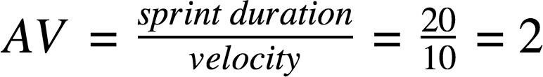

PROJECT PLANNING

BURNDOWN CHART

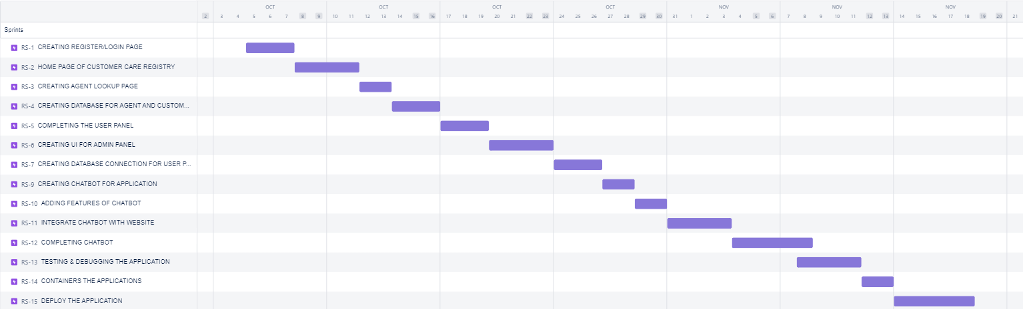



**Thank you**